“Online Treatment Guide(OTG)
A Knowledgebase Expert System”


Session (2013-2015)

Program
Masters in Computer Science (MCS)

Submitted By:
Faiza Rasheed ............1963
Zainab Waheed .........1987

Supervised By
Mr Jawad Khan Jadoon
(Lecturer at Hazara University Havelian Campus)
Department of information Technology

HAZARA UNIVERSITY, HAVELIAN
1.1 Project Title “Online Treatment Guide(OTG)”

1.2 Project Overview Statement
This project is aimed at developing an Online Treatment Guide(OTG) that is ofimportanceto a person who wants to know about the information (name ,address, timing ,contact no) related to specialist or doctors of the chosen disease in area near and around Abbottabad City and Havelian.
OTG also provides help to persons who don’t knows about their disease but only familiar about their symptoms and wants to aware about their disease without having a session with a specialist, in such case they just needs to enter symptoms in search bar then disease will be shown and related doctors or specialist of that disease in selected area would be display.
OTG can help someone to identify their diseases on the basis of symptoms as well as help to identify one or more doctors who meet their specific needs.
Online Treatment Guide is a purely web based application.

1.2 Proposed System:
The proposed systemwill provide web base online treatment guide in Abbottabad and Havelian City, Pakistan.
We propose to do this by applying knowledge base expert system. Our strategy is to use technology to help mankind by providing free of cost and time effective online medical guide. Sometimes finding the right doctor can be difficult. There's a whole number of things to take into consideration before visiting a doc: e.g. which doctors are most convenient for you to visit, which can diagnose you best. By using the proposed system there is no need to visit different places in order to collect information about concerned physician (that who is best for u) or one doesn’t require a physical tour to the doctor or specialist to take time for the check up he can manage all this anyway by using OTG.
OTG is an effort to help the people to find disease and related doctors or specialist of disease in atd and hvn.

2.1 Modules of Software:
1) Usage Verification:
Firstly a person needs to full fill usage verification criteria in order to seek info from OTG.
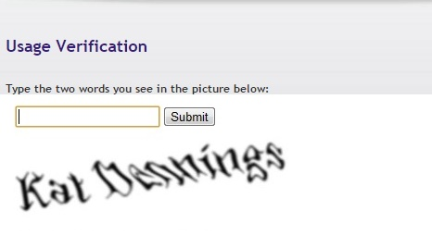
2) Select Location:
Secondly a person has to selecta city.
>>Abbottabad City.
>>Havelian City.

Only two areas will be covered in the proposed system. After selecting an area a page appears on which following two modules are given.

3) Diagnose Diseases by symptoms.
Major common diseases are covered in this section. There is just need to type symptoms in search bar then OTG expert system will diagnose disease on the basis of symptoms.



4) Find A Doctor.
>> Find doctor by specialty.
>>Find doctor by name.
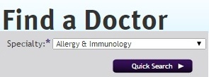

Here one’s only needs to type the specialty of the doctor in search bar then doctor name and each n every information related to the doctor would display i.e. specialty of the doctor ,clinic address timing as well as contact no.

3.1 Existing System:
There is no such kind of system exists that provides online medical services in area of abbottabad and havelian. There is not a complete list of all doctors in atd and havelian is available on the web .If someone wants to know about his disease & physician or specialist info, he needs a physical tour of the areas in order to find an appropriate doctor info which is much difficult and time wasting.

3.1.1 Limitations:
The existing methodology of finding or locating a doctor or physician is tricky, stressful as well as demands a physical tour of related area in order to find a doctor or an advisor which is much difficult and time consuming.

Conclusion:
OTG is an on-line source of information for persons seeking treatment facilities in Abbottabad and Havelian .One can find healthcare profesionalist through a web connection without leaving home.
In nutshell, we can say that OTG serve as disease locator(symptom checker) as well as doctor locator.

Software Environment:
Automatic Tools:
Back End Programming Tools:
  - ASP.NET
  - MY SQL

Semi Automatic Tools:
Supporting Tools:
  - Dreamweaver.
  - Microsoft Office.
  - Internet.

Hardware Environment:

  - Processor : Core 2 duo
  - RAM : 2.0 GB
  - Harddisk : 250 GB

